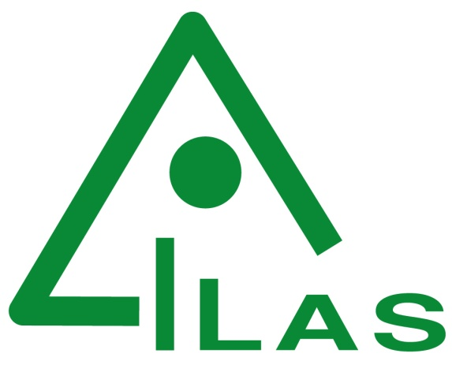
The Institute of Laboratory Animal Sciences (ILAS) is a unique research organization dedicated to research on laboratory animals and comparative medicine. It is affiliated with the Chinese Academy of Medical Sciences (CAMS) and Peking Union Medical College (PUMC). It was founded in 1980, when China has just begun to develop laboratory animal sciences. ILAS currently has 478 staff working in four main business areas: scientific research; laboratory animal resource development conservation and production; comparative medicine technology services; and teaching and training.
Organization
The scientific research centers of ILAS focus primarily on research and breeding of novel laboratory animal resources, comparative medicine research on human diseases (including neurodegenerative diseases, cardiovascular diseases, cancer, metabolic diseases, immune system diseases, skin diseases, HIV, TB, Flu, HBV and new infectious diseases such as Zika and MERS), and research on the transformation of new medical products (PDX, intestinal microecology and stem cells, etc.)
ILAS also provides technical services for scientists and researchers engaged in life sciences, particularly medicine and pharmaceutical research. The platforms offered by ILAS include creation of new animal models; supply of animals for medical research; specialised phenotypic analyses of animal models; and preclinical evaluation of new pharmaceuticals.
ILAS has two National Testing Centers; the Laboratory Animal Pathology Testing Center and the Laboratory Animal Environment Testing Center. These two centers have established China's laboratory animal quality management system. In addition, ILAS has four Key Laboratories, each of which carries out unique functions in China. The first is dedicated to Comparative Medicine of Human Diseases. The second uses animal models for scientific evaluation of Chinese Traditional Medicines. The third specializes in the development and application of new animal models of infectious diseases, while the fourth promotes commercial applications or opportunities based on animal models developed at ILAS.
Scientific Research
Scientific highlights achieved by ILAS researchers include establishment of:
- a system of laboratory animal disciplines in China, including research and technology based on genetics, microbiology, pathology and breeding;
- a national laboratory animal quality inspection system;
- the discipline of comparative medicine including a comparative medical technology system;
- an animal model technology system for infectious diseases providing a technology platform for the prevention and control of major and emerging infectious diseases in China;
- a rapid gene knock-in service for both rats and mice;
- a system for evaluation of new vaccines and drugs to deal with newly arising infectious diseases.
Laboratory Animal Resources
ILAS has particular strengths in maintaining animal resources, including:
- the world’s largest genetically diverse mouse resource;
- the most animal models of infectious diseases in the world;
- the second largest number of genetically engineered rat models in the world;
- China’s only resource library of animal models of human diseases.
Education and Training
ILAS has taken a lead role in education and training in laboratory animal sciences in China, with the following achievements:
- the first Chinese institution for teaching this discipline;
- the first institution in China for training of laboratory animal science and technology specialists;
- providing the Editor-in-Chief of the eight-year series of teaching materials planned by the Ministry of Health, "Laboratory Animal Sciences" and the postgraduate textbook "Medical Laboratory Sciences";
- producing an annual report on the development of Laboratory Animal Sciences in China;
- providing specialist training for the Chinese Association for Laboratory Animal Sciences;
- service by Prof. Chuan Qin as the co-chair of the Education and Training Committee of International Council for Laboratory Animal Science (ICLAS);
- establishing the first international specialist training base in Asia;
- publication of three national academic journals, named Acta Laboratorium Animalis Scientia Sinica, Chinese Journal of Comparative Medicine and Animal Models and Experimental Medicine (AMEM).
In addition to its research and training efforts, ILAS believes it is important to set standards of animal welfare, so the first Institutional Animal Care And Use Committee of Laboratory Animal Science in China was established. The aim of this Committee is to build an advanced management system for the use of laboratory animals throughout the country.

