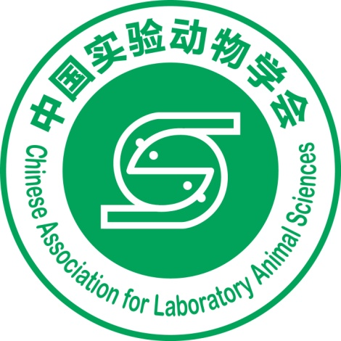
The Chinese Association for Laboratory Animal Sciences (CALAS) was founded in 1987. Qian Xin-zhong, the former minister of the Ministry of Health, was the president of the first session of the Council. CALAS has now completed seven sessions of the Council. The current president is Prof. Chuan Qin, the director of the Institute of Laboratory Animal Sciences, Chinese Academy of Medical Sciences (CAMS) & Peking Union Medical College (PUMC).
CALAS oversees 16 work committees, such as the Academic Committee, Journal and Information Committee, International Exchange and Cooperation Committee, as well as 16 professional committees, e.g. Laboratory Animal Welfare and Ethics Professional Committee and Laboratory Animal Standardization Professional Committee.
As a national academic association in the laboratory animal sciences field, CALAS plays an important role in promoting academic standards and, leading the development of the discipline and providing services to scientific and technical workers, to society and to the government. CALAS has worked successfully to establish a wide range of activities, including academic exchanges, science popularization and dissemination, a scientific award program, science and technology demonstrations, and education and training. It supports and safeguards public health and national security, especially in the prevention and control of infectious diseases, bio-safety, and establishment of animal models of disease.
CALAS is a founding member of the Asian Federation of Laboratory Animal Science Associations (AFLAS), and initiated and provides the training base of AFLAS.
CALAS is also the scientific member of the International Council for Laboratory Animal Science (ICLAS). The president of CALAS, Prof. Chuan Qin, was previously the President and is now the vice-president of AFLAS, and is a governing board member of ICLAS.
CALAS founded two journals, Acta Laboratorium Animalis Scientia Sinica in 1993 and Chinese Journal of Comparative Medicine in 1991. Both are listed in the Chinese statistical source journals of science and technology and in the Guide to the Core Chinese Periodicals. In 2016, the editorial office of CALAS won funding to prepare for the launch of a new English-language journal, Animal Models and Experimental Medicine.

